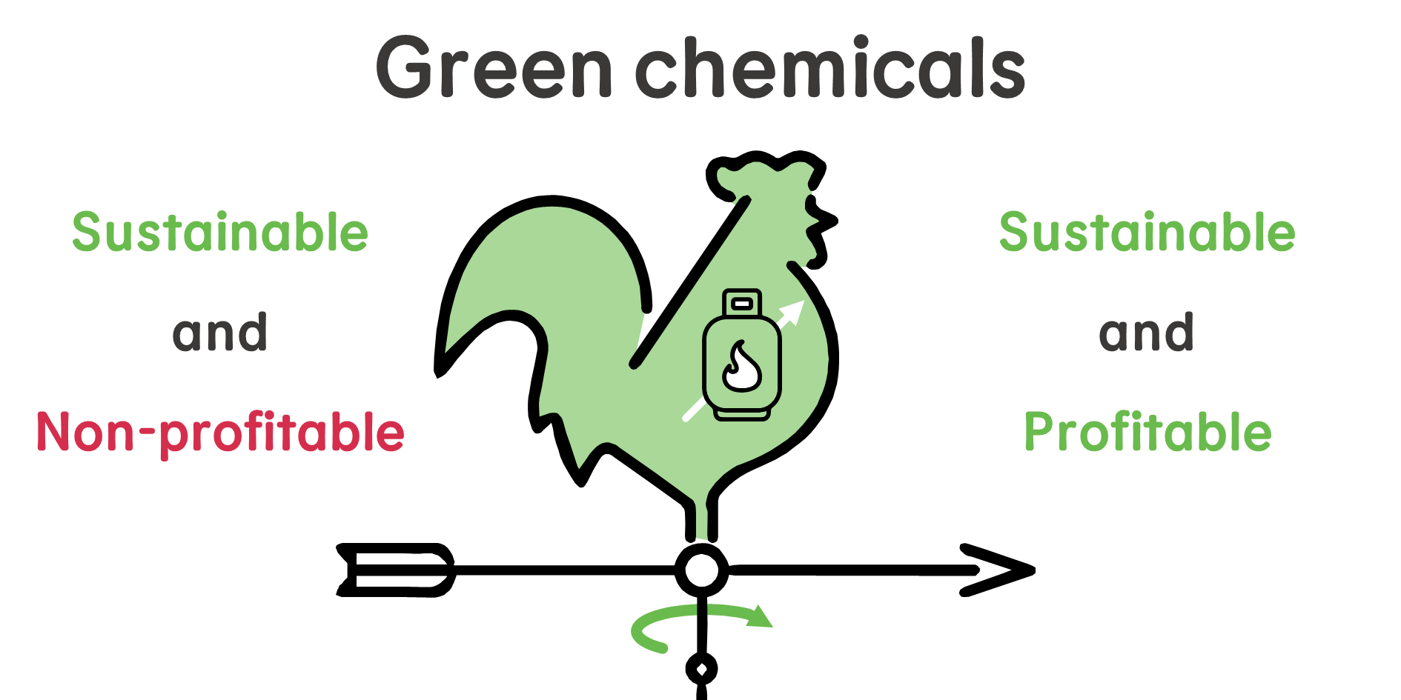
Europe's energy crisis has made green routes for ammonia and methanol synthesis economically competitive. This presents an opportunity for Europe to lead the grand transition towards a sustainable chemical industry.
I am bothered by the indistinctive use of green and sustainable along the article

